Assignment Cover Sheet

To be completed electronically by the student and submitted with each piece of work. Please upload this completed cover sheet via Turnitin

Assignment Title: Machine learning model & supporting documentation – 60%
Tutor: Usman Ahmad
Student Name: Naomi Chellsea Espiritu
Student Number: 639876
Date of Submission: 7th January 2026
Details of your submission:
This is my Assessment 2 project, which contains two links (my kaggle notebooks and github link)
Kaggle Link | Github Link

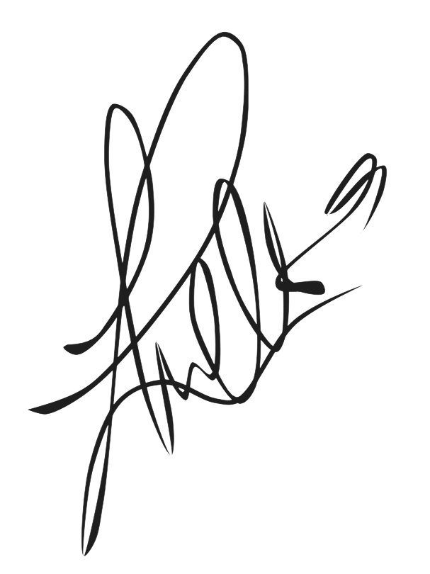
In submitting this assignment, I am confirming that I have read and understood the regulations for assessment, and I am aware of the seriousness with which the University regards unfair practice. Please see the universities Unfair Practice Policy for details.

Signed: Date: 7th January 2026

Customer Segmentation Analysis: Online Retail

- Introduction
In the highly dynamic area of e-commerce, customer support is often more cost-effective than acquisition. However, treating all customers identically, such as sending the same email offers or promotions, is inefficient and can lead to customer churn. The core problem that is addressed in this model is the lack of actionable insight into the customer base of the provided Online Retail Dataset.
To solve this, I developed a machine learning model using K-means Clustering. The main goal was to segment customers based on their purchasing behaviour, specifically utilizing the Recency, Frequency, and Monetary Framework (RFM). This approach allows the business to identify the “High Value” customers to retain, then “At Risk” customers to re-engage, and “Low Value” customers to reduce the priority, thereby optimizing marketing ROI (Return on Investment).

- Data Preprocessing
The dataset contained transactional records including InvoiceNo, StockCode, Quantity, InvoiceDate, UnitPrice, and CustomerID.

2.1 Data Cleaning Strategy
I have identified significant data quality issues upon the first exploration. This requires rigorous cleaning to ensure the validity of the model:
- Missing Identification: Approximately 25% of the rows had missing CustomerIDs, since the objective is customer segmentation, anonymous transactions provide no value for retention strategies. In the end, I have dropped these rows.
- Cancellations and Returns: I have observed that there are invoices starting with “C” and negative quantities. These represent cancelled orders. Including these would distort the “Monetary” and “Frequency” metrics, so these were filtered out. (Eg: customer was buying and returned an item 10 times would appear to have high frequency.)

2.2 The RFM model
Machine Learning algorithms cannot process raw transactional logs directly. I have aggregated the data by CustomerID to create 3 new features:
- Recency: Calculated as the number of days between the snapshot date (last recorded + 1 day) and the customer’s latest purchase. (Lower values are better)
- Frequency: The count of unique InvoiceNo entries per customer. (Higher values are better)
- Monetary: The sum of Quantity * UnitPrice for all transactions. (Higher values are better)

- Techniques
3.1 Handling Skewness
During the visualisation phase, I have observed that the data followed a Pareto distribution (Power law). The majority of customers made 1-2 purchases, while a “long tail” of outliers made hundreds. K-Means uses Euclidean distance to find cluster centers that, if left undressed, these extreme outliers would force the algorithm to create clusters just for them.
To mitigate this, I applied a Log Transformation (np.log1p) to the RFM variables. This compressed the scale, transforming the skewed distribution into a more normal distribution (Gaussian-like)

3.2 Standardization
Monetary values (ranging from 0 to 250,000) are numerically much larger than Frequency (1 to 100), the K-Means algorithm would inherently weigh “Monetary” as the only important feature. I applied StandardScaler to ensure all three features contributed equally to the distance calculations.

3.3 Algorithm Selection
I selected K-Means Clustering because of its efficiency with medium-sized datasets and its interpretability. To validate the optimal number of clusters, I integrated 2 methods:
- The Elbow Method: I plotted the WCSS or Within-Cluster Sum of Squares against K. I looked for the elbow point where adding another cluster yielded diminishing returns in reducing variance.
- Silhouette Analysis: This metric measures how similar an object is to its own cluster compared to other clusters.

- Model Development and Results
The Silhouette Score Analysis initially suggested k=2 as the mathematically optimal number of clusters. However, a critical evaluation of a 2-cluster model revealed it was functionally limited as it simply divided customers into “Active” vs “Inactive”.
From a corporate perspective, this binary classification lacks nuance. I proceeded with k=3, which the Elbow Method supported as a viable secondary option. This allowed for the identification of a crucial “Middle” tier of customers. Those who are active but have the potential to grow.

4.1 Snake Plot Analysis
Using the Snake Plot to visualize the standardized feature vectors (Z-scores), I identified the following segments:
- Cluster 1: “The Champions” (High Value)
This group (Pink Line) exhibits the lowest Recency (bought recently), but the highest frequency and highest monetary value.
These are the most valuable assets. The strategy should focus on retention through loyalty promotions. (Loyalty gift cards)
- Cluster 0: “The Hibernating” (At Risk)
This group (Cyan line) has high Recency (hasn’t been seen in months), low Frequency, and low Spend.
Marketing spend should be minimized here or limited to aggressive “comeback” campaigns ( “we miss you” coupons)
- Cluster 2: “The Potentials” (Growth)
This group (Yellow Line) hovers around the average for Recency and Spend.
This is the target for upsell strategies, product recommendations could effectively push them into the “Champion” level.

4.2 PCA (Dimensionality Reduction)
To visualize the separation of these groups, I applied Principal Component Analysis (PCA). By reducing the 3D RFM vectors into 2 Principal Components, I plotted the clusters on a 2D scatter plot. This plot confirms that while “Champions” and “Hibernating” customers were well-separated, there was some overlap with the “Potentials” indicating that customer behaviour is a spectrum rather than rigid buckets.

- Gradio Interface
To demonstrate the practical utility of my project model beyond static analysis, I have developed an interactive prototype using Gradio. This interface allows marketing managers to input raw customer data, such as “Recency: 10 (days), Spend: 500 (AED)”, and will receive an instant segmentation prediction.

The technical implementation ensures robustness by replicating the full preprocessing pipeline, like raw inputs are first Log-Transformed and then Scaled using the saved StandardScaler parameters before being passed to the K-Means predictor.
This prevents data leakage and ensures data protection logic matches the training phase exactly. The system outputs both the predicted segment (eg: Champions) and a specific strategic recommendation (eg: Offer VIP access) and bridging the gap between data science and corporate operations.

- Critical Reflection
While my implementation successfully segmented the customer base, there are still several limitations that must be recognized.

1. Limitations of K-Means
One significant challenge I have encountered was the geometric assumption of the K-Means algorithm. K-Means assumes that clusters are spherical and of roughly equal size. However, when I visualized the data using PCA, it became clear that the real customer behaviour was often irregular. The PCA visualization showed that the "Champion" cluster was more sparse than the dense "Hibernating" cluster.

A density-based algorithm like DBSCAN might have handled these irregularities better by identifying outliers as "noise" rather than forcing them into a cluster.

2. The Static Nature of RFM

Currently, this model represents a static snapshot in time. A customer classified as a "Champion" today could become "At Risk" next month without the system detecting the transition until the next run. The model also lacks of context regarding seasonality. For example, a customer who only buys during Christmas might be unfairly penalized for high Recency in July, leading to incorrect segmentation.

To improve:

If I were to expand this model further, I would focus on these areas including:
Integration of Unstructured Data: Currently, I only look at how much they bought, not what they bought. Integrating the text descriptions using NLP techniques could reveal distinguished segments like Parents vs Gift Buyers.

Longitudinal Analysis: To solve the static data issue, I would implementing a moving-window approach to track how customers migrate between clusters over time would provide an "Early Warning System" for churn.

- Conclusion
My project demonstrated that machine learning can effectively decode complex customer behaviour. By rigorously cleaning the data, normalizing skewed distributions and applying K-Means clustering, I transformed raw transactional logs into 3 distinct actionable customer personas. This provides the business with a data-driven foundation for personalized marketing strategies.

